**EXPERIMENT 9**

**AIM:** To perform CRUD operations using MongoDB

**THEORY:**

**MongoDB:**

MongoDB is an open-source document-oriented database that provides high performance, high availability, and automatic scaling. It is an open source product, developed and supported by a company named 10gen. Document databases are highly flexible, allowing variations in the structure of documents and storing documents that are partially complete. One document can have others embedded in it. Fields in a document is like columns in SQL, they can be indexed to increase search performance. MongoDB was built on a scale-out architecture, a structure that allows many small machines to work together to create fast systems and handle huge amounts of data.

**Features of MongoDB**

These are some important features of MongoDB:

1. **Support ad hoc queries:** In MongoDB, you can search by field, range query and it also supports regular expression searches.
2. **Indexing:** You can index any field in a document.
3. **Replication:** MongoDB supports Master Slave replication. A master can perform Reads and Writes and a Slave copies data from the master and can only be used for reads or back up (not writes)
4. **Duplication of data:** MongoDB can run over multiple servers. The data is duplicated to keep the system up and also keep its running condition in case of hardware failure.
5. **Load balancing:** It has an automatic load balancing configuration because of data placed in shards.
6. Supports map reduce and aggregation tools.
7. It also supports JSON data model with dynamic schemas, Auto-sharding for horizontal scalability, Built in replication for high availability.

**Advantages:**

1. Higher Performance Levels
2. High Speed and Higher Availability of data
3. Easy Environment and a Quick Set-up
4. Flexibility with schema
5. Sharding while handling large databases
6. Supports Horizontal Scalability
7. Offers an enhanced Ad-hoc Queries feature

**Disadvantages:**

1. MongoDB uses multi-document ACID (Atomicity, Consistency, Isolation, and Durability) transactions.
2. Joining documents in MongoDB can very tedious.
3. In case if the indexing is implemented incorrectly or has any discrepancies, MongoDB will perform at a very low speed. Fixing the errors in the indexes would also consume time.
4. Allows a limited size of only 16 MB for a document
5. MongoDB requires a high amount of storage due to the lack of joins functionalities which lead to the duplication of data.

**CODE:**

1. use bdi

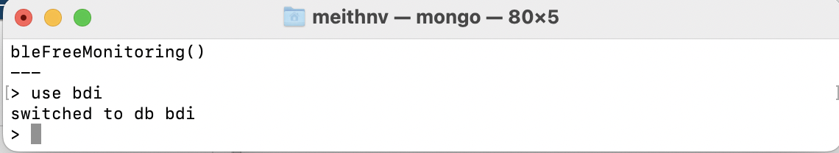

1. db



1. show dbs;



1. db.createCollection("BDI-Pracs");



1. db.createCollection("BDI-Prac2s" , {capped:true , size:6142800, max:1000});



1. show collections



1. db.employees.insert(

{empId: 1, name: 'Jerry', dept: 'Athletics' , best:0.56 }

);

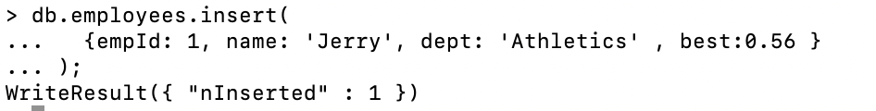

1. db.employees.insertMany([

{empId: 1, name: 'Jack', dept: 'Comps' , degree:'BTech' },

{empId: 2, name: 'James', dept: 'IT', degree:'BTech' },

{empId: 3, name: 'Rusky', dept: 'EXTC' } ,

{empId: 5, name: 'Harry', dept: 'Magic', salary:6000, type:'Dark' },

{empId: 4, name: 'Lily', dept: 'Fashion', salary:10000 },

{empId: 6, name: 'Beast', dept: 'Comps' , salary:6543 },

{empId: 7, name: 'Snape', dept: 'Magic' , salary:100 , type:'Defence' },

{empId: 8, name: 'Beast', dept: 'Comps' , salary:40000 , degree:'MTech'},

{empId: 9, name: 'Lily', dept: 'Fashion' , salary:14576 },

{empId:10, name: 'Tom', dept: 'Fashion' , salary:99999 }

]);

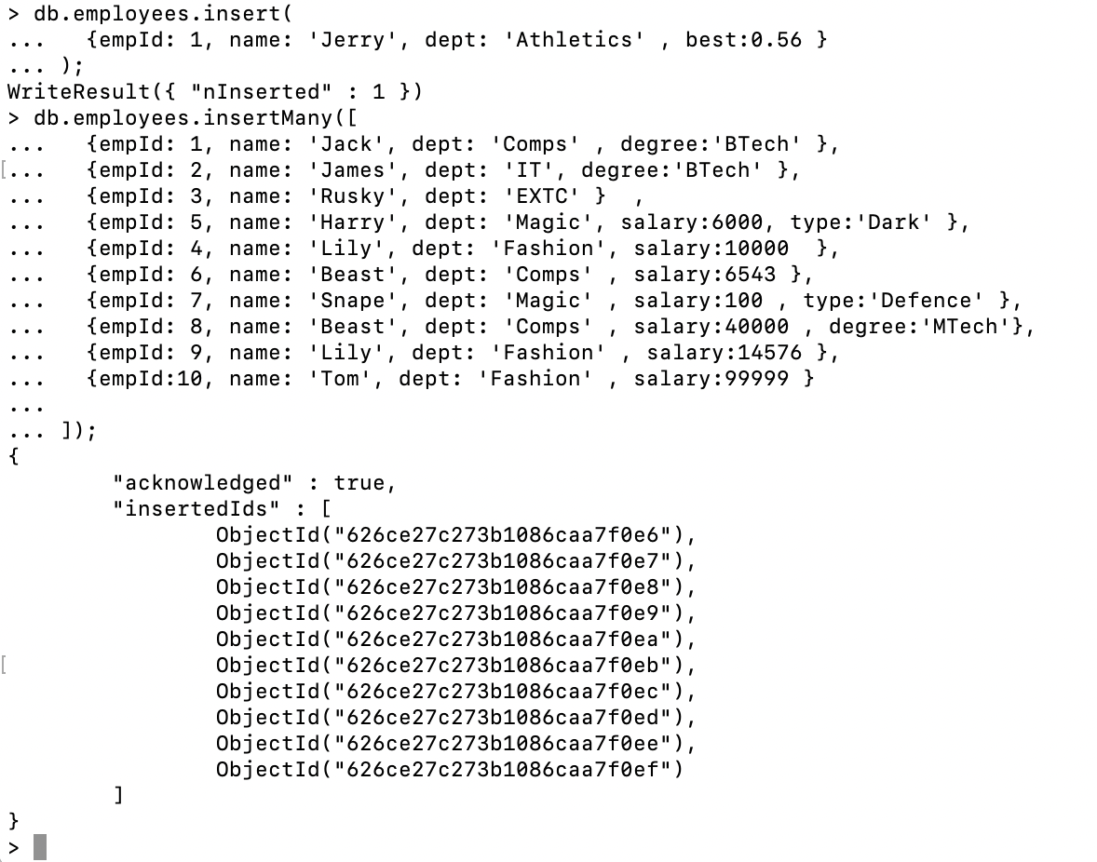

1. db.employees.find()

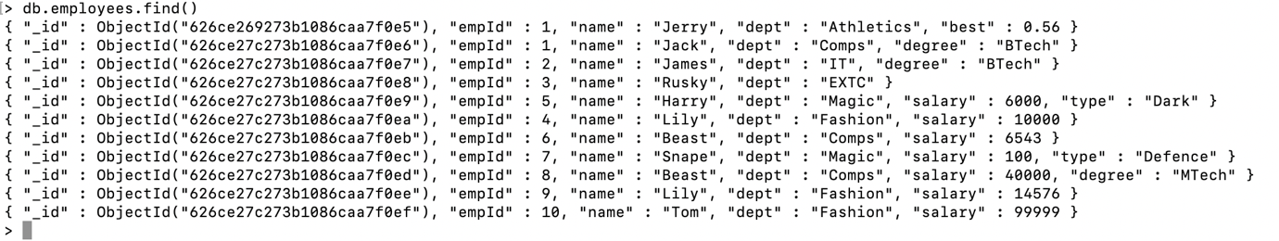

1. db.employees.find().pretty();

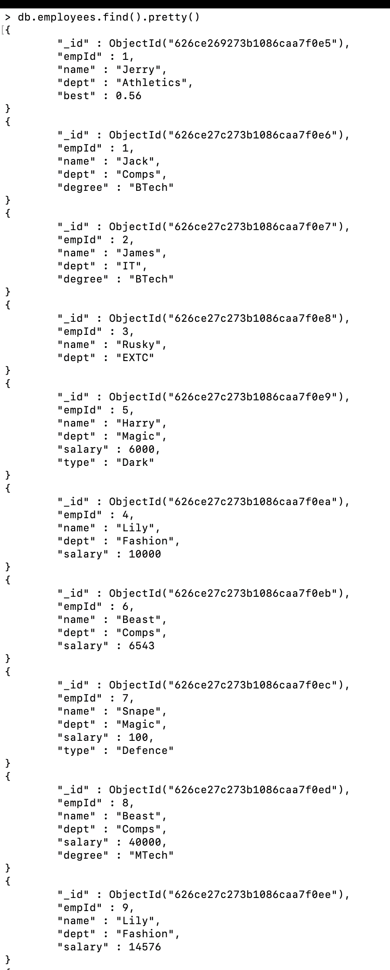

1. db.employees.find({name:Harry});



1. db.employees.find({ salary:{ $gt:6000} });

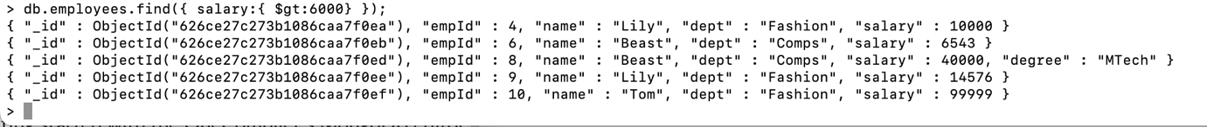

1. db.employees.findOne({ salary:{ $gt:6000} });

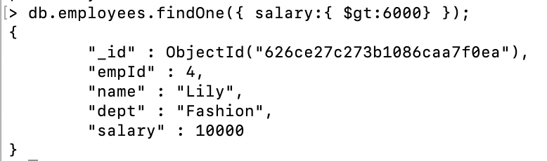

1. db.employees.updateOne(

{empId: 3 },

{ $set: { salary: 9 } }

);

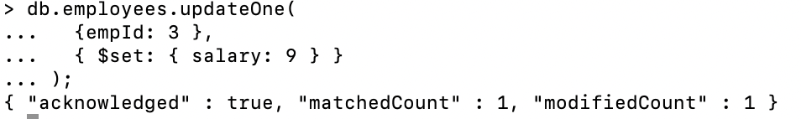

1. db.employees.updateMany(

{degree: 'BTech' },

{ $set: { project: 'Website' } }

);

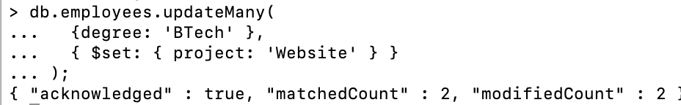

1. db.employees.find().sort({dept:1}).pretty()



1. db.employees.find().sort({name:-1}).pretty();



1. db.employees.aggregate({ $group: {_id:"$dept" , Counts:{$sum: 1}} })

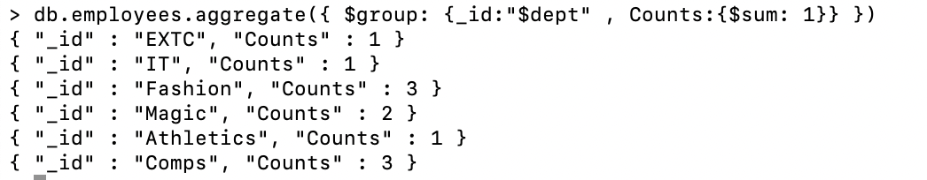

1. db.managers.insertMany([

{empId: 101,name:'HeadN' , dept: 'EXTC'},

{empId: 102, name: 'Head1', dept: 'IT' },

{empId: 103, name: 'Head2', dept: 'Comps' } ,

{empId: 105, name: 'Head3', dept: 'Magic' },

{empId: 104, name: 'Head4', dept: 'Fashion' },

{empId: 106, name: 'Head5', dept: 'Athletics' }

]);

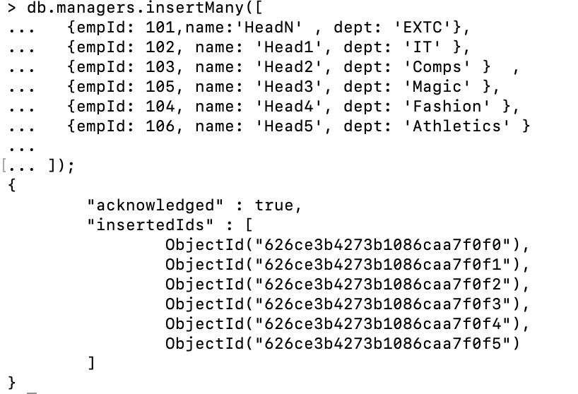

1. JOIN

db.managers.aggregate([{ $lookup: {

from: "employees" ,

localField:"dept",

foreignField:"dept",

as:"mergeddept"

}

}]).pretty();

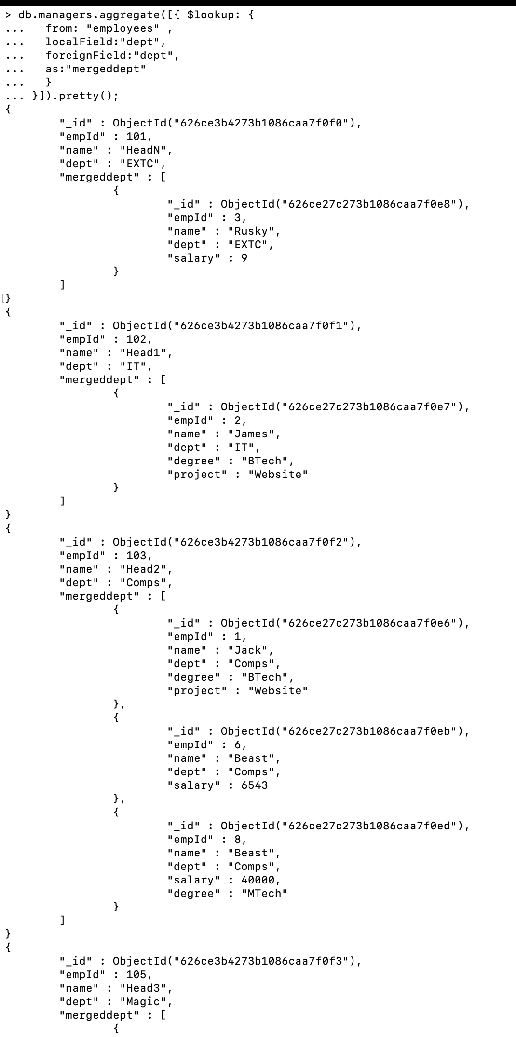

1. db.employees.drop();



1. db.dropDatabase();

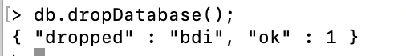

**CONCLUSION:**

In this experiment, we explored and learnt about mongoDB, a noSQL database. We learnt about the mongo queries for performing CRUD operations. The experiment was performed on the mongo shell and the code and the output for the had been observed and attached. Thus, by the virtue of the experiment, we implemented and learnt about mongoDB and it’s commands.